**Creating the eggPlant Environment**

This section describes the initial set-up of eggPlant and systems-under-test. If you have already installed eggPlant and enabled VNC connections with your systems-under-test, please see the next section.

**Installing eggPlant**

**Installing eggPlant on Mac**

**Mac OS X System requirements**

Mac OS 10.6 or later (Intel only)

**Installation**

1. Download eggPlant from the [TestPlant Downloads](http://www.testplant.com/downloads) page.
2. Drag the Eggplant ‘dmg’ file into your Applications folder.

**Tip**: For quick access to eggPlant, drag the eggPlant icon from the Applications folder into your Dock.

**Installing eggPlant on Linux**

**Linux System requirements**

* Processor: Intel x86 32-bit or 64-bit with 32-bit system libraries
* RAM: 1 GB or more
* One of the following Linux distributions:
  + RedHat Enterprise Server 5+
  + Fedora 13+
  + Debian 5+
  + Ubuntu 10.10, 11.10, and 12.04

For inquiries about other distributions of Linux, please e-mail [TestPlant support](mailto:support%40testplant.com?subject=).

**Installation**

1. Download eggPlant for your Linux distribution from the [TestPlant Downloads](http://www.testplant.com/downloads) page.
2. Unpack the eggPlant archive.
3. Install the eggPlant package with a package manager.

**Installing eggPlant on Windows**

**Windows System requirements**

* Processor: 1.5 GHz or faster
* RAM: 1 GB or more
* Operating System: Windows XP Service Pack 2 or 3, Windows Vista, Windows 7, Windows 8, or Windows Server 2008

For inquiries about other Windows operating systems, please e-mail [TestPlant support](mailto:support%40testplant.com?subject=).

**Installation**

1. Download the eggPlant installer from the [TestPlant Downloads](http://www.testplant.com/downloads) page.
2. Double-click the eggPlant installer.

**Licensing**

The first time you launch eggPlant, you must enter a license key:

1. Enter the Key and User Name that you received from TestPlant.
2. Click the Add button.
3. To read the licensing agreement, choose Eggplant or Info menu > Licenses. By running eggPlant you are implicitly agreeing to the terms of the licensing agreement.

If you don’t have a license key, click the Free Trial button to request a trial license.

**Sharing a license between user accounts**

**Mac OS X and Linux**

By default, your eggPlant license is stored in the */Library/Eggplant* directory, which is accessible to all user accounts. However, if the user who installs eggPlant does not have permission to write to that directory, the license is stored in the user’s own Library directory. To make the license accessible to all users, someone with the appropriate permissions must move the license to */Library/Eggplant.*

**Windows**

By default, your eggPlant license is stored in the *C:\Library\Eggplant* directory, which is accessible to all user accounts. However, if the user who installs eggPlant does not have permission to write to that directory, the license is stored in the user’s own Library directory. To make the license accessible to all users, someone with the appropriate permissions must move the license to *C:\Library\Eggplant* *.*

**eggPlant Preferences**

EggPlant Preferences are stored by individual user account on the eggPlant computer.

**Launching eggPlant on Linux**

If you are using the GNOME desktop environment, you can launch eggPlant from the launcher menu; otherwise, open a terminal and type the name *eggplant*.

**Installing a VNC Server**

VNC stands for Virtual Network Computing. The VNC Server is installed on the System-Under-Test (SUT) and works with eggPlant to allow control of this second machine.

**VNC Checklist**

VNC server installation varies from system to system, but this section contains a checklist for general VNC configuration, and notes about specific VNC servers.

Top of Form

 Install a standard VNC server (up to RFB protocol 3.8.)  
  
 Verify that your network security will allow the SUT to receive connections from eggPlant on one of the VNC ports: 5900-5909.  
  
 If the VNC server requires that clients have a user account on the SUT, create an account that the eggPlant users can log in to.  
  
 Make a note of the following information to enter in eggPlant’s Connection List:

* The SUT’s IP address or host name
* The SUT’s VNC port number
* The name and password of a user account on the SUT, if the VNC server requires it
* The VNC server password (if there is no user-account password)

Bottom of Form

**Common VNC Servers**

| **Platform** | **Server** | **Notes** |
| --- | --- | --- |
| Linux | Built-in VNC servers |  |
| Mac OS X | Vine Server from TestPlant | If Apple Remote Desktop is running on your SUT, port 5900 is not available for VNC connections. If you do not need to run Apple Remote Desktop, we recommend that you turn it off; otherwise, remember to use a VNC port other than 5900. |
| Windows 7, Windows Vista | RealVNC Personal Edition, RealVNC Enterprise Edition, and UltraVNC | RealVNC Personal Edition does not currently run in Service mode on Windows 7 and Windows Vista; if you are using RealVNC Personal Edition, you must run it in User mode. |
| Windows XP | RealVNC Free Edition,  RealVNC Personal Edition, RealVNC Enterprise Edition, and UltraVNC | RealVNC Personal Edition runs in both User mode and Service mode on Windows XP. |

**Step-By-Step Instructions for VNC Server Installation**

**Installing RealVNC Server 5.0.2 on Windows**

(The example below is on Windows 7)

1. Go to realvnc.com and download RealVNC 5.0.2 for Windows. You can use the Free version, or one of the commercial versions. The commercial versions offer more features but these are not strictly necessary for VNC connection with eggPlant.

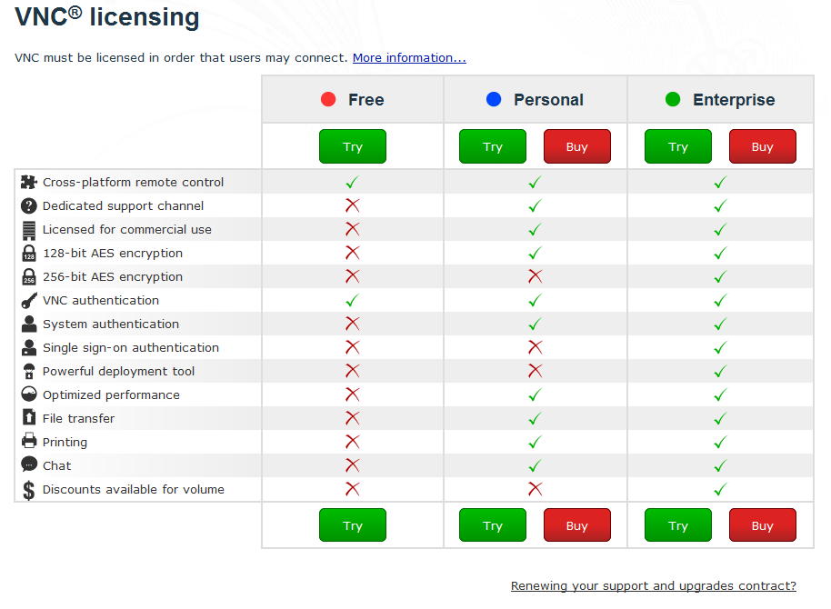

1. Get a license from the website by clicking on the button shown below (you can also obtain a license later in the process after installation).
2. Open the downloaded package from the downloads folder on your machine.
3. Follow the installation instructions.
4. To configure a password, open the RealVNC Server and click "More" and then select "Options". This will bring up a panel that allows you to set a password for the connection.

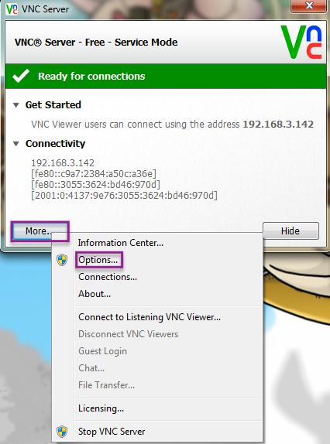

1. To License, click "More" and then "Licensing", and follow the instructions, using the license key you have obtained from the RealVNC website.

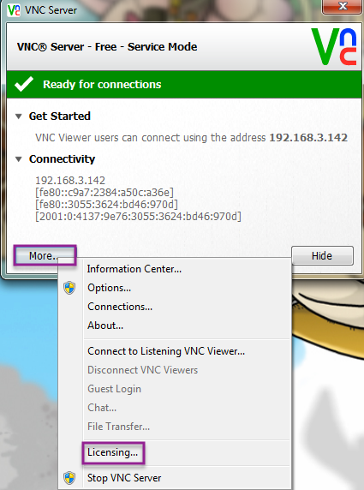

1. To set the UDP port communication, click "More" and "Options" and then "Advanced".

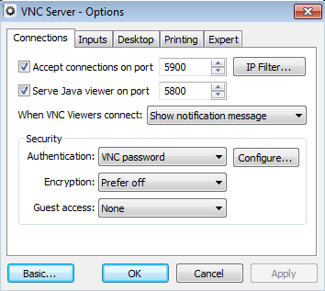

**Installing Vine 4.0 on Mac**

(The example below is on Mac OS 10.7 Lion)

1. Download the latest version of Vine VNC from the TestPlant Downloads page.
2. Open the .dmg package.
3. Drag the Vine icon that appears into your Applications folder, and/or your Dock.

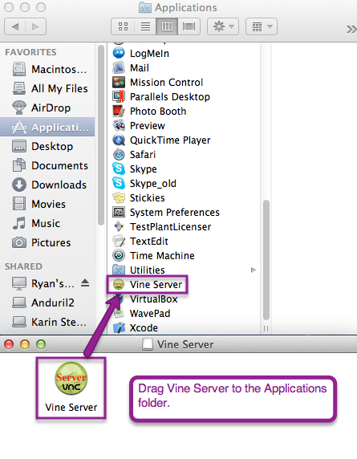

1. Launch Vine. Make sure that it is set up to communicate on the correct port (usually 5900).

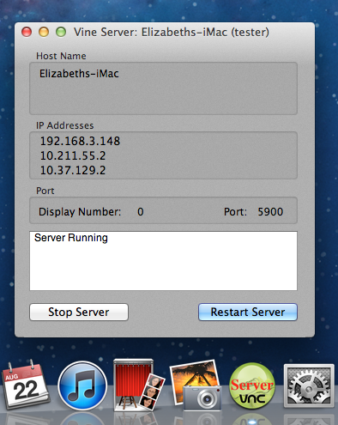

**Using Built-In VNC on Ubuntu**

(The example below is on Ubuntu 12.04)

1. Open Desktop Sharing, which can be found under Applications.
2. Select "Allow other users to view your desktop".  
   Optional - de-select "You must confirm each access to this machine", so that you do not have to approve the connection from the Ubuntu machine every time.

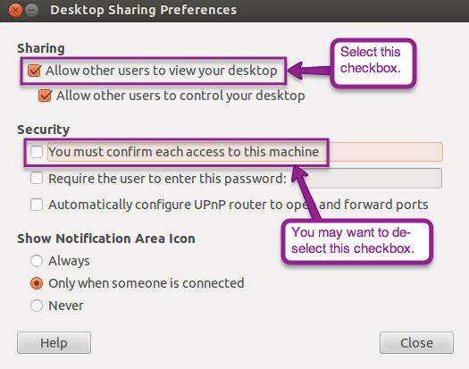

1. If you are not seeing updates in the Remote Screen Window from the eggPlant side, log out of the Ubuntu user account, and click the gear next to the log in field.

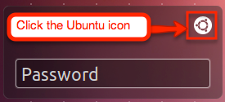

Then select "Ubuntu 2D". This will disable some desktop effects, and allow the VNC to send updates of the screen to eggPlant.